**LAB 1: FAMILIRIZATION WITH PHOTOPEA TOOLS**

In this lab, we used photopea for getting the knowledge about basic photo editing tools.Photopea is a web based photo editor and image enhancer.

TOOLS USED:

* Spot healing brush tool: Used for enhancing the previous blurred pixels and removing it and keeping the pixels surrounding the neighbour area.
* Lasso tool: Used lasso tool for removing the eye of the duck by selecting it and filling it with content area that removes the selected pixel and replaces it with surrounding pixel.
* Burn tool: Used for increasing the overall darkness of the image as shown in the after image
* 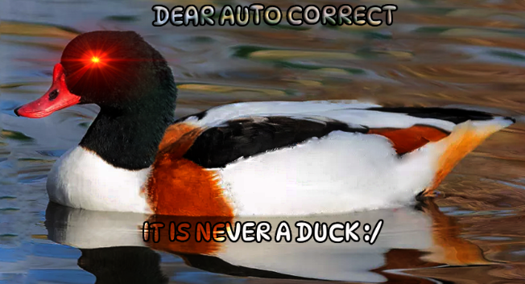Text tool: It was used for keeping the required text with the overlay being screen so the text color matches with the surrounding image.

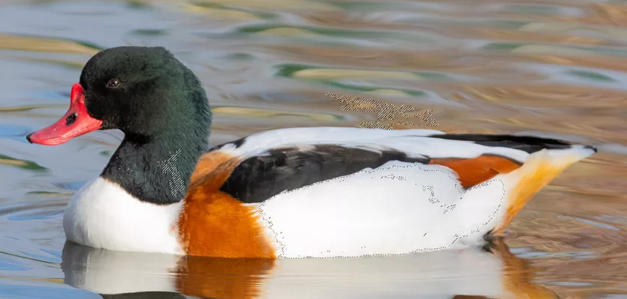

AFTER

BEFORE

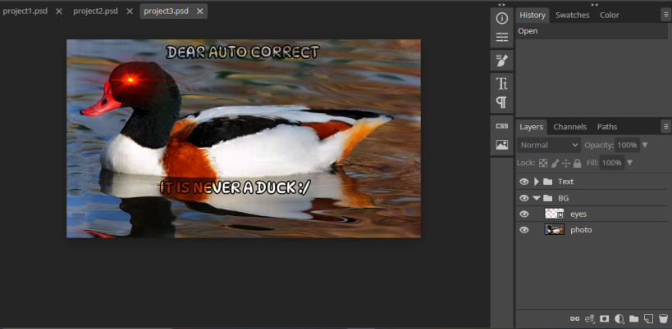

EDITING PROCESS

At the end, we grouped all the text and images in their respective folder accordingly. Point to be noted, is that all the editing was done after creating a duplicate layer of the photo and doing all the editing in the duplicate layer.